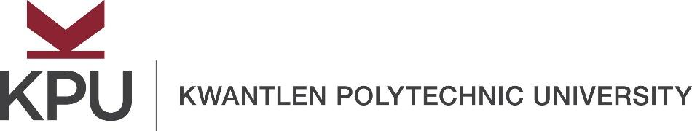
Subject Line: Create open curriculum. Receive gift cards!

Dear Students:

I invite you to participate in a focus group with students from Douglas, KPU, Langara, and TRU in order to help create free and open learning materials. Please help us find out if creating open pedagogy inspires you to care more.

Please click the link below to provide your contact information, to answer a few questions in order to create your profile and to give your consent to the research project.
Link: https://www.surveymonkey.ca/r/FGQLTKR

What is the focus group?
In a series of two to three task-oriented meetings with other students, of 2.5 hours each session, you will create open pedagogy in the form of cases for class discussion. The cases will probably be about social issues if your focus group agrees. You will be asked to talk openly. You will be lightly guided to make decisions, to brainstorm, to source images, sounds and open education resources, to create visuals, to write, to revise, to remix and to role play. In the process, you will also reflect upon your feelings about the process in the focus group.

The data from your initial questionnaire, your focus group and your reflections will be analyzed. We want to see if we can find ways of encouraging care between students, between teachers and students and for everyone in the learning community. Will that care happen when you work in groups creating learner-centred, free, open pedagogy that classes in BC can use? Please help us find out.

Why should I participate?
Once the research is complete, and the learning materials are written, the open pedagogy could be used in post secondary institutions in BC and published as an open education book. You could be acknowledged by name as a co-author of the open resource/book. You will have written a student resource! You will have helped to create caring, relevant, realistic, culturally responsive study materials to help students learn. You will have had a fulfilling learning experience yourself in the process. Also, you will receive a $30 gift card.

Should I be concerned about participating?
The research is voluntary; the research participants are self-selected and the research is not connected to any grades or GPA. There is more detailed information about the project and a consent form on the front page of the enrollment questionnaire.

Again, here is the link: https://www.surveymonkey.ca/r/FGQLTKR

Persons to contact
If you have questions about the study, please contact the principal investigator, Deirdre Maultsaid, Applied Communications Faculty, KPU, at Deirdre.Maultsaid@kpu.ca.

If you have any concerns or complaints about your rights as a research participant and/or your experiences while participating in this study, contact Kwantlen Polytechnic University’s Research Ethics Board at 604.599.3163 or reb@kpu.ca. The approved Research Ethics Board application number is Ethics ID: H21-01455.

Thank you,

