**Foregrounding Indigenous Perspectives**

**Community and Collaborator Affinities and Conflicts in Open Education**

## Facebook & Twitter

**Text:** Have you participated in the creation of Canadian Indigenous Open Educational Resources? You are invited to participate in a 15 minute survey: <https://bit.ly/indigenousOER>

*Note: A share or like will publicly identify your interest in the study.*

**Image:**

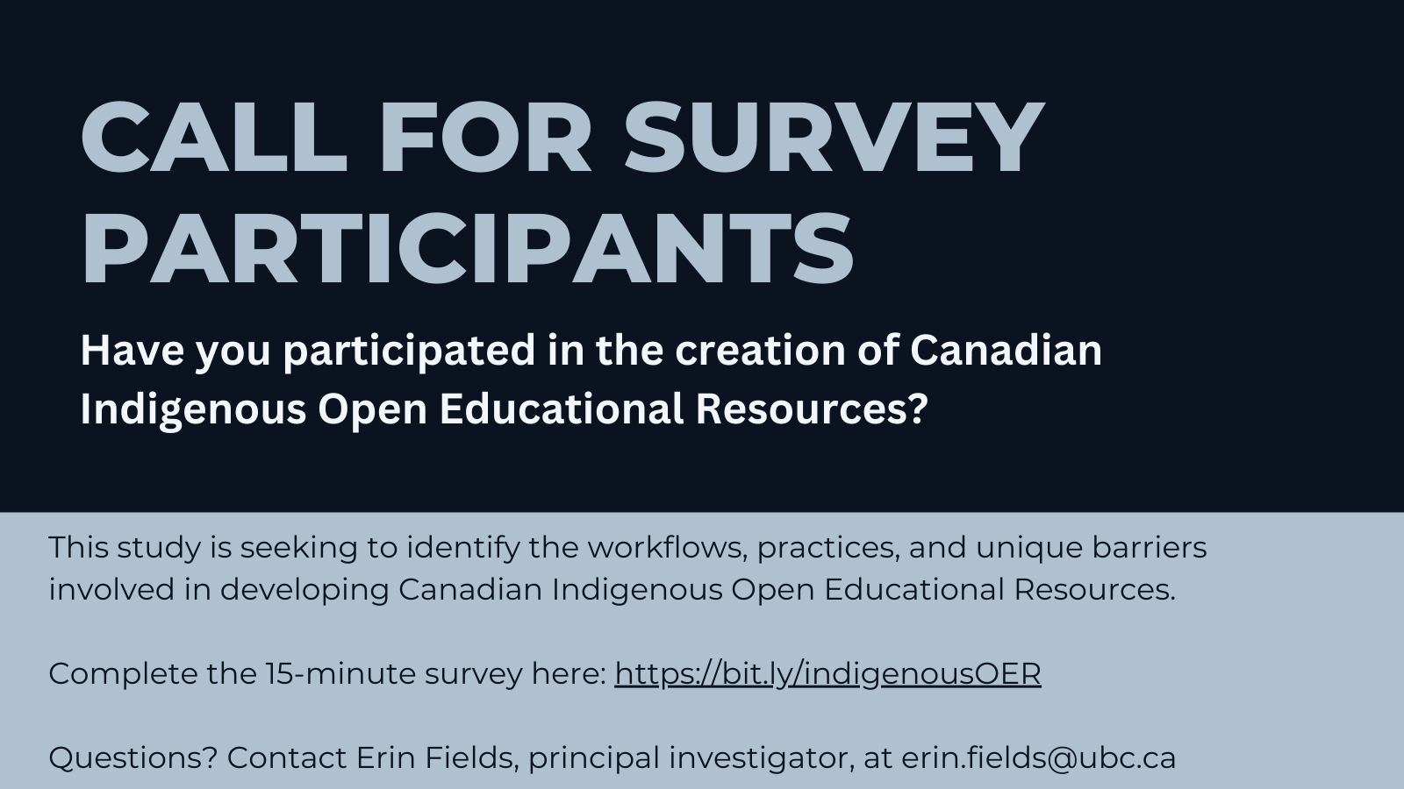

## Instagram

**Text:** Have you participated in the creation of Canadian Indigenous Open Educational Resources? You are invited to participate in a 15 minute survey: <https://bit.ly/indigenousOER>

*Note: A share or like will publicly identify your interest in the study.*

Image:

