Foregrounding Indigenous Perspectives
Community and Collaborator Affinities and Conflicts in Open Education

Facebook & Twitter
Text: Are you employed by or affiliated with an institution of higher education? Do you self-identify as Indigenous? You are invited to participate in a 60-minute interview about Canadian Indigenous Open Educational Resources. Express your interest here: https://bit.ly/IndigenousOER_EOI
Note: A share or like will publicly identify your interest in the study.
Image:
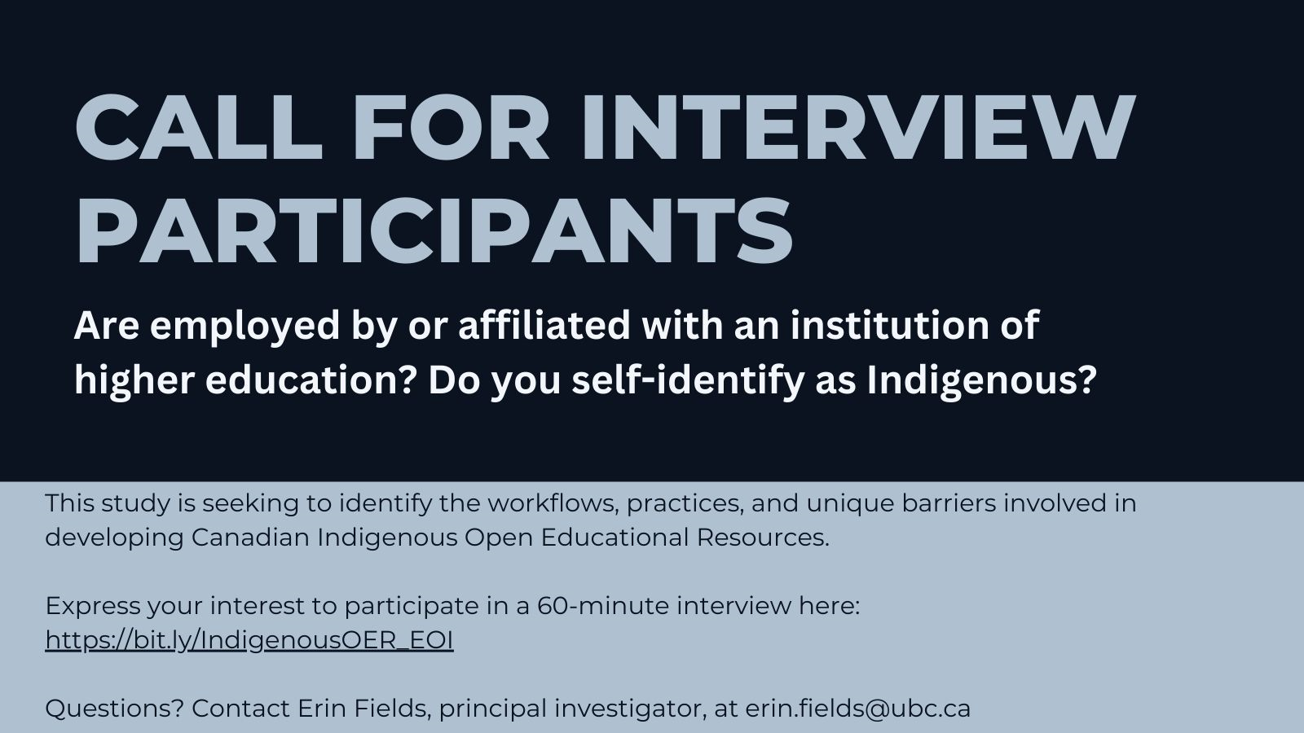

Instagram
Text: Are you employed by or affiliated with an institution of higher education? Do you self-identify as Indigenous? You are invited to participate in a 60-minute interview about Canadian Indigenous Open Educational Resources. Express your interest here: https://bit.ly/indigenousOER_EOI
Note: A share or like will publicly identify your interest in the study.
Image:

