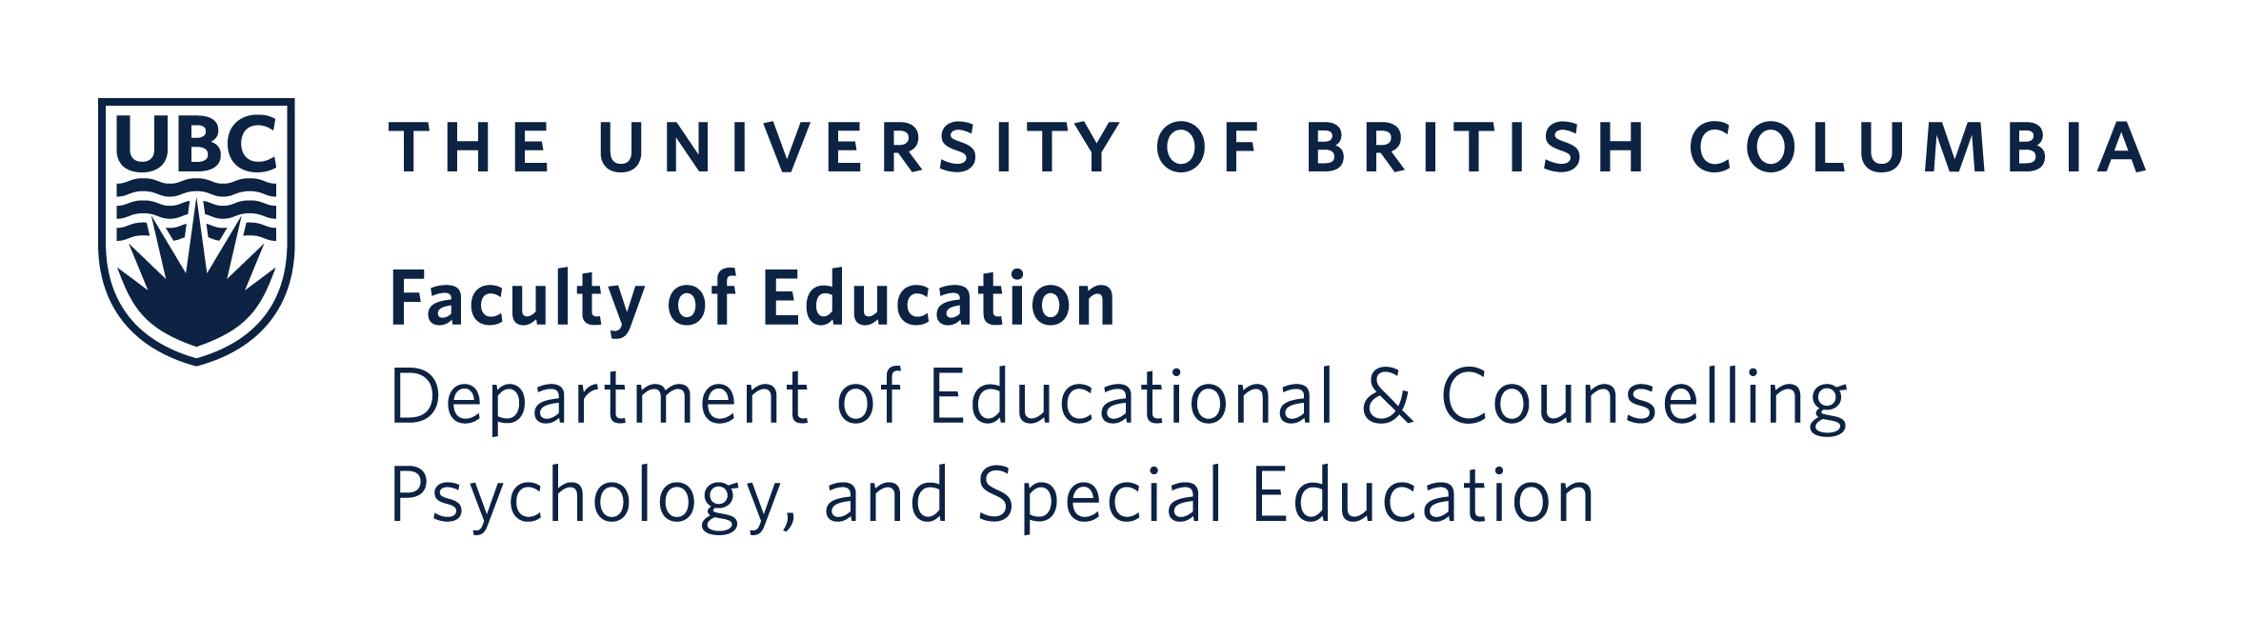
Vancouver Campus
2125 Main Mall
Vancouver, BC Canada V6T 1Z4
Tel: 604.822.3131 Fax: 604.822.2684
Phone 604 822 0242
Fax 604 822 3302

Dear Student,

This is an invitation for you to participate in an online survey designed to measure the impact of open textbook adoption on post-secondary students in BC. You are receiving this invitation because you are enrolled in a course that may be using an open textbook.

This research is being conducted by Dr. Surita Jhangiani, a faculty member in the Department of Educational & Counselling Psychology & Special Education in the Faculty of Education and Dr. Carolee Clyne, Learning Strategy Consultant.

Please click on the following link to read the letter of informed consent and participate in the survey:

https://ubc.ca1.qualtrics.com/jfe/form/SV_1zgGSbs6rIQF9Mq

The survey should take about 10 minutes to complete. At the end of the survey, you will be given an opportunity to enter your email address into a draw to receive one of ten $25 gift certificates. Your email address is stored separately from the survey results and is not linked in any way to your responses.

Please consider participating in this survey. Your answers will help us build a picture of how open textbooks impact the educational outcomes of students in B.C. The results of this online survey will help university instructors, administrators, student associations, policymakers, government officials, and other stakeholders make more informed decisions about the adoption of open textbooks.

If you have any questions or comments about this study, please contact the Principal Investigator, Dr. Surita Jhangiani, Assistant Professor of Teaching, Faculty of Education (surita.jhangiani@ubc.ca) or Dr. Carolee Clyne, Learning Strategy Consultant (cclyne@bccampus.ca). If you have any concerns or complaints about your rights as a research participant and/or your experiences while participating in this study, contact the Research Participant Complaint Line in the UBC Office of Research Ethics at 604-822-8598 or e-mail RSIL@ors.ubc.ca or call toll free 1-877-822-8598.

Thank you,

Surita Jhangiani, Ph.D.
& Carolee Clyne, Ph D.

Ethics Id: (BREB# H21-03641)

