**Science Literacy Week Wikipedia Edit-A-Thon**

**Canada 150 – Canadian Science & Scientists**

**How to Participate:**

Even if you’ve never edited Wikipedia before you can join in our edit-a-thon –

1. Create a no-strings attached Wikipedia account.

Wikipedia requires only a username and password to create an account – even an email is optional, so no personal information is required. The Create Account link is on the top right of the Wikipedia.org main page.

<https://en.wikipedia.org/w/index.php?title=Special:CreateAccount&returnto=Main+Page>

1. Register for the Science Literacy Week Wikipedia Edit-a-Thon with your Wikipedia username so your edits will be counted. Google “BC/SciLit17” and you’ll be brought to the MeetUp page. Scroll down to How to participate, select 2, Register via the Dashboard.  
   <https://outreachdashboard.wmflabs.org/courses/BC/Science_Literacy_Week_BC_Edit-athon_(September_18-24,_2017)?enroll=iugqfnhx>
2. Create a new entry or edit an existing one.

The theme for this Edit-a-Thon is Canadian Science and Scientists, and more specifically, science and scientists from British Columbia.

There are a number of ways you can contribute to Wikipedia. You can create or enhance Wikipedia articles, copyedit, add external links, verify and update citations, and assist with research.

1. Join us in the library from 1 - 2 during Science Literacy Week (September 18-22) and we can edit together, or you can do it remotely, from wherever you are, anytime that week

**Editing Tips:**

**Things to keep in mind when editing:**

1. Articles should have a neutral point of view – it’s an encyclopedia.
2. Information should be verifiable – facts need to be cited with reliable secondary sources.
3. Entries should be notable – already written about in reputable sources.
4. No original research.

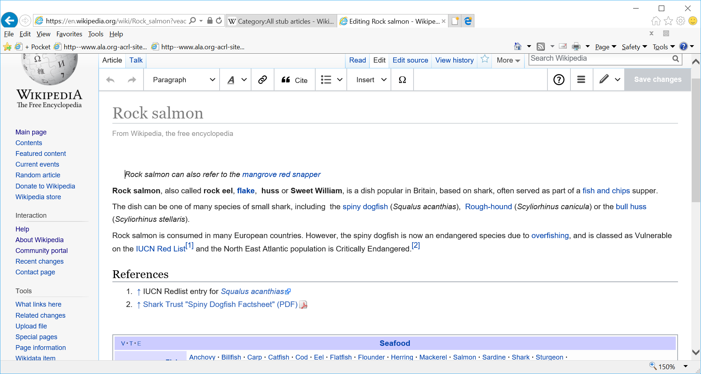

**Editing an existing article**

Find the article you want to edit, and select edit, from the tabs on the top left.

Wikipedia has a Visual Editor so it’s almost as easy as MS Word.

**Citation**

The cite button provides a template for you to add a citation and will automatically format and number it for you.

**Categories**

Adding a category can help keep pages together. This has to be done in in Source Editing – click the pencil icon in the top row right, switch to source editing, at the bottom of the page type [[Category:Category Name]]

For example, people or innovations related to BCIT should be categorized with British Columbia Institute of Technology, you would do this by typing this, in Source Editing mode, at the bottom of the page:

[[Category:British Columbia Institute of Technology]]

Wikipedia has created an easy to follow tutorial that covers the basics of editing: <https://en.wikipedia.org/wiki/Wikipedia:Tutorial>

(or google Wikipedia tutorial)

**Edit an existing entry – places to start:**

Editing an existing entry is a good way to get your feet wet!

Since anyone can edit Wikipedia, there are many entries that could use some improvement, from copy editing, to adding content, to adding citations.

Here are some places to start if you want to:

**Copyedit**

<https://en.wikipedia.org/wiki/Category:Wikipedia_articles_needing_copy_edit>

Go to Google, type in a topic of your choice, the words “This article may require [copy editing](https://en.wikipedia.org/wiki/Wikipedia:Basic_copyediting)” (in quotes) and site:Wikipedia.org

**Add Content to an Existing Article**

<https://en.wikipedia.org/wiki/Category:All_stub_articles>

Go to Google, type in a topic of your choice, the words “*This article is a* [*stub*](https://en.wikipedia.org/wiki/Wikipedia:Stub)*. You can help Wikipedia by* [*expanding it*](https://en.wikipedia.org/w/index.php?title=Reverse_sexism&action=edit)*.*” (in quotes) and site:Wikipedia.org

**Add Citation to an Existing Article**

All facts in Wikipedia should be verifiable by a reliable secondary source. Many articles need citations.

There is a citation hunt game you can use to find a random article that needs a citation. <https://tools.wmflabs.org/citationhunt/en?id=6ec80c1e&cat=all>

Go to Google, type in a topic of your choice, the words “*needs citation*” (in quotes) and site:Wikipedia.org

**Creating a New Entry**

This link will step you through creating a new entry.

<https://en.wikipedia.org/wiki/Wikipedia:Your_first_article>

Or google Wikipedia your first article.

The theme for this edit-a-thon is Canada 150, so we are focusing on Canadian Science & Scientists. We have picked out some BCIT related topics, but if you have one in mind, go for it….

Nancy Paris

Sheila Early

Maureen Connelly

Jennie Moore

MAKE+

Fitsum Tariku

Jaimie Borisoff

Paula Brown

Hassan Farhangi

Add BCIT as a category for Mark Angelo - <https://en.wikipedia.org/wiki/Mark_Angelo>

FSA?

Clean up the BCIT entry so it’s accurate (…CARI is mentioned in the BCIT article as a “notable recent addition”!)

BCIT Technology Centre (now CARI, and was 25 years old when BCIT was 50)

Expand on Guichon Creek - <https://en.wikipedia.org/wiki/Guichon_Creek_(Still_Creek)>

Smart Microgrid (including OASIS)